CIS 302

A JavaScript Calculator

1. Add the GitHub Page Link

https://aydingursoy.github.io/Aydin-Gursoy/

1. Add a screenshot of the Calculator displayed in a browser – include the address bar, using the given codes. Use notepad++

1. Add a screenshot of your modified version of the Calculator

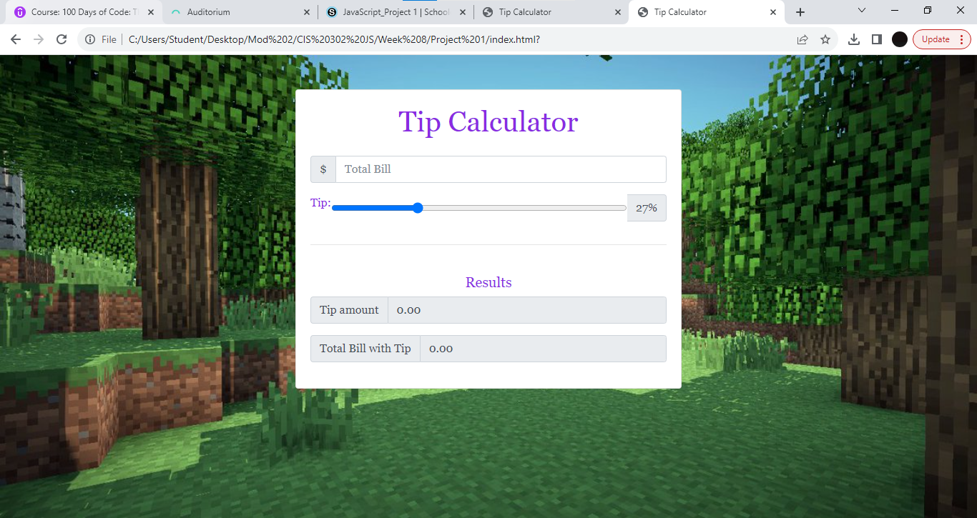

1. What change(s) did you make?

I added a background image, fitted the image, changed the text color and changed the text font.